Ideation Phase
Empathize & Discover
Date | 24 October 2026
Team ID | [Individual Project Submission]
Project Name | IMovies — Movie Ticket Booking Made Simple
Maximum Marks | 4 Marks

Empathy Map Canvas: Understand the needs, frustrations, behaviors, and expectations of moviegoers looking to discover movies, check showtimes, select seats interactively in real time, and book tickets smoothly through an online movie ticket booking platform like IMovies.
Reference: https://www.mural.co/templates/empathy-map-canvas
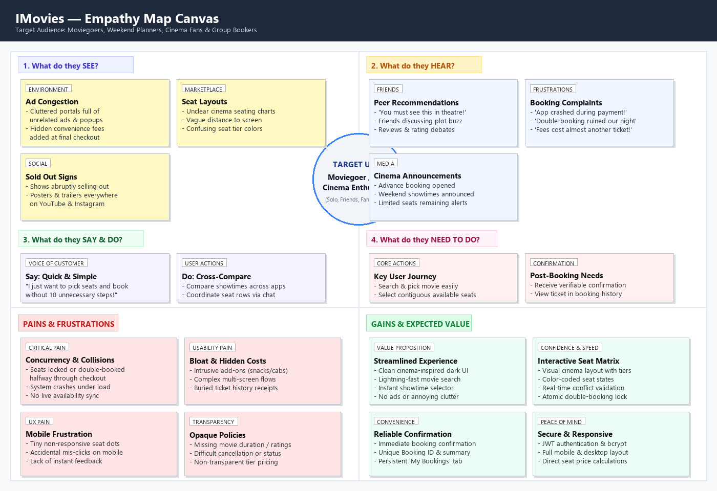
Figure 1.1: IMovies Empathy Map Canvas (Target Audience: Moviegoers & Group Bookers)
1. Target User Personas
To ensure that IMovies addresses genuine user requirements, three distinct primary user personas were identified and modeled during the empathize & discover stage:
- Persona 1: Alex Rivera (Frequent Cinema Enthusiast): A 23-year-old university student who frequently plans weekend cinema outings with friends. Seeks a fast, clutter-free mobile booking experience, transparent pricing without hidden upselling, and clear adjacent seat selection for group movie nights.
- Persona 2: Sarah Jenkins (Working Professional & Family Planner): A 34-year-old marketing manager who arranges weekend movie trips for her family. Needs comprehensive movie details (genre, runtime, synopsis), straightforward showtime comparisons across halls, and instant booking confirmations for stress-free theatre check-in.
- Persona 3: Rohan Patel (Spontaneous Evening Moviegoer): A 28-year-old software engineer who books evening movie tickets spontaneously after work. Requires live, synchronized seat availability to avoid seat collision errors and double-booking mid-checkout.
2. Detailed Empathy Map Breakdown
A. What Users SEE (Marketplace & Interface Environment)
- Ad-Heavy Portals: Ticketing portals heavily cluttered with third-party commercial banners, popups, and aggressive upselling for unrelated merchandise and expensive concessions.
- Ambiguous Seating Charts: Complex, poorly rendered cinema seating charts where booked, selected, and available seats are difficult to differentiate on desktop and mobile screens.
- Hidden Convenience Charges: Sudden price jumps and convenience charges appearing at the final payment step, causing sticker shock.
- Premature Availability Lags: Showtimes marked as open that abruptly change to 'Sold Out' only after the user spends several minutes selecting seats.
B. What Users HEAR (Social Buzz & Word-of-Mouth)
- Peer Recommendations: Friends and coworkers discussing the latest blockbuster trailers, trending reviews, and urging them to book early before popular weekend shows sell out.
- Booking App Frustrations: Frequent complaints from peers regarding buggy checkout processes, system freezes during high-demand releases, and lost seat reservations.
- Influencer & Critic Buzz: Critic reviews and audience ratings on platforms like YouTube, IMDb, and Reddit influencing which showtimes and formats (Standard, VIP) to choose.
C. What Users SAY and DO (Observable Behaviors)
- Direct Quote: "I just want to see what movies are showing near me tonight without having to click through 10 cluttered promotional pages."
- Direct Quote: "Why is it so hard to see if two seats are actually side-by-side on this mobile screen?"
- Direct Quote: "I hate selecting seats only to be told at the final checkout screen that someone else took them seconds ago."
- Cross-Platform Comparison: Users regularly browse 2-3 different cinema websites simultaneously to compare ticket prices and show schedules.
- Confirmation Screenshotting: Users capture phone screenshots of booking confirmation screens because retrieval through platform dashboards is unreliable.
D. What Users THINK and FEEL (Internal Drivers & Emotions)
- Pains — Clutter & Friction: High frustration with intrusive ads, complex checkout funnels, and unhelpful error messages.
- Pains — Seat Concurrency Anxieties: Anxiety caused by potential double-booking or seat loss during high-traffic booking windows due to lack of atomic transaction checks.
- Pains — Opaque Booking History: Dissatisfaction when past booking records or active ticket references cannot be quickly accessed from their user profile.
- Gains — Simplicity & Speed: Desire for a sleek, cinema-inspired dark UI with rapid search and single-click showtime exploration.
- Gains — Visual Seating Confidence: Confidence through an interactive, color-coded seat selection grid with real-time availability validation.
- Gains — Verifiable Confirmation: Peace of mind through an instant booking confirmation card containing an immutable Booking Reference ID and complete show details.
3. Traceability to IMovies Solution Architecture
The insights uncovered in this Empathy Map directly dictate the functional and non-functional requirements of IMovies:
- Clean Dark Cinema UI: Directly eliminates clutter and visual fatigue, addressing the observed user frustration with commercial bloat.
- Interactive Seating Matrix: Provides visual seat selection with distinct color codes (Green for Selected, Dark Gray for Available, Crimson for Booked).
- Backend Double-Booking Prevention: Directly solves the primary user anxiety of seat collisions and mid-checkout failures through atomic validation.
- Dedicated 'My Bookings' Dashboard: Satisfies the user's need for easy ticket retrieval without relying on third-party email delivery.

